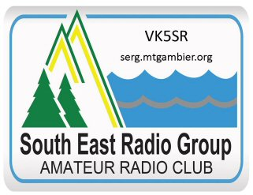
South East Radio Group
PO Box 1103
Mount Gambier 5290

President: Colin Hutchesson. VK5DK
Secretary: Col Huon. VK5HCF

Volunteer policy and Risk Management – South East Radio Group

Volunteers are reminded of the danger of electricity (when working on their electronic equipment), overhead wires (when working on antennas) and the need for certification if climbing a club tower or one that is used by the club.
Each working bee will have a safety officer appointed. This person will advise volunteers on safe practices.
All members are covered by the Wireless Institute of Australia Insurance Scheme either through their membership of the WIA or through an additional amount paid by the club for non-members through our affiliation with the National Body.
Additional non-member volunteers are covered by our Public risk Insurance when on documented working bees. All volunteers are reminded of the wisdom of personal insurance cover and are asked about their training in the relevant area when an exercise is likely to be hazardous e.g. tower climbing.
As members frequently volunteer at external events such as Generations of Jazz and the Mount Gambier Hill Climb and other motor sport events. Safety briefing sessions will be conducted by our event coordinator and all volunteers must attend these.
Volunteers will normally provide their own food, transport, accommodation or shelter when on club events. They are expected to be Sun smart and responsible for their own safety in accordance with club briefings.
Travel and registration for training
Volunteers will normally not be paid for travel when on working bees with the exception of attending training courses required by the club or for repeater maintenance. Training courses will be at the cost of the club if it is for gaining accreditation for the Amateur Service examination service.
Repeater maintenance travel may be paid on request for one vehicle per occasion for maintenance involving travel exceeding 199km round trip.
Travel re-imbursements will be made on receipt of a written application stating the circumstances, vehicle type/size, date and time. The amount will be based on a fair estimate of petrol/diesel costs for the trip.
Appreciation
Volunteers will be acknowledged and thanked by the event coordinator, the President at a meeting and the club will continue its recognition program through the President Appreciation Award and the Roy Goodwin Foundation Licensee shields presented at the AGM each year.

