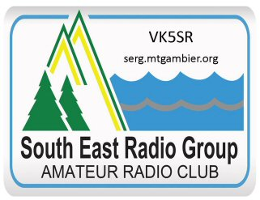
South East Radio Group
PO Box 1103
Mount Gambier 5290

President: Colin Hutchesson. VK5DK
Secretary: Col Huon. VK5HCF

DISABILITY ACTION POLICY

The South East Radio Group (SERG) recognises that it is unlawful to treat a person with a disability less favourably than a person who does not have a disability, in the same or similar circumstances. Such discrimination is covered by the Commonwealth Disability Discrimination Act 1992 and the Equal Opportunity Act 1995.

Disability covers:
- Physical.
- Intellectual.
- Psychiatric.
- Sensory.
- Neurological or learning difficulties.
- Beneficiaries of workers compensation.

SERG embraces the Disability Discrimination Act 1992 premise that:
- people with disabilities are part of our diverse communities.
- people with disabilities, their families and carers have a right to participate as fully as possible in the life of our communities .
- people with disabilities are the primary source of information regarding the physical, social and cultural barriers to their participation in their local community.

SERG will develop and implement a Disability Action Plan which will focus on those physical, social & cultural barriers which create a handicap for people with disabilities to be able to enjoy amateur radio at our Club.

Basic elements of the Disability Action Plan will include:
- Education of Club members and visitors.
- Identifying specific issues at our Club that can make life unnecessarily difficult or complicated for people with disabilities.
- Develop strategies to deal with these issues.
- Annual review to ensure the actions remain appropriate and effective

