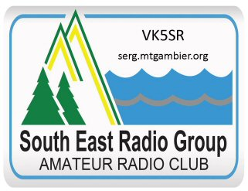
South East Radio Group
PO Box 1103
Mount Gambier 5290

President: Colin Hutchesson. VK5DK
Secretary: Col Huon. VK5HCF

The Radio Amateur’s Code of Ethics

The Radio Amateur is:
Considerate
He/She never knowingly operates in such a way as to lessen the pleasure of others.
Loyal
He offers loyalty, encouragement and support to other amateurs, local clubs, the Wireless Institute of Australia though which Amateur Radio in Australia is represented nationally and internationally.
Progressive
With knowledge abreast of science, a well-built and efficient station, and operation above reproach.
Friendly
Slow and patient operating when requested; friendly advice and counsel to the beginner; kindly assistance, cooperation and consideration for the interests of others. These are the hallmarks of the amateur spirit.
Balanced
Radio is an avocation, never interfering with duties owed to the family, job, school or community.
Patriotic
His/her station and skills are always ready for service to country and community.
Law abiding
He/she obeys the regulations governing the amateur service.

